+91 9115095002



1 77777 66666

*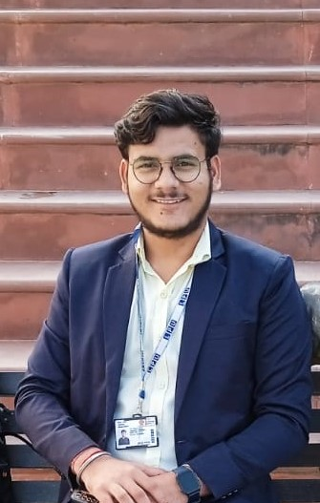*

AKSHAY SHUKLA

www.linkedin.com/in/akshay24

akshay2002@gmail.com



WEB DEVELOPER

Ayodhya Uttar Pradesh



https://github.com/akshayshuklagit



TECHNICAL SKILLS

Programming languages:

Python , C

Web Technologies:

HTML, CSS , JAVASCRIPT

Data Management:

MySQL

CERTIFICATIONS

* Certification in Full Stack web development by LinkdeIn
* Certified in Python by Guvi and partnership with google for education
* And also Certified in python bootchamp by Lepses
* Certification in Sql with database by Great learning

POWER SKILLS

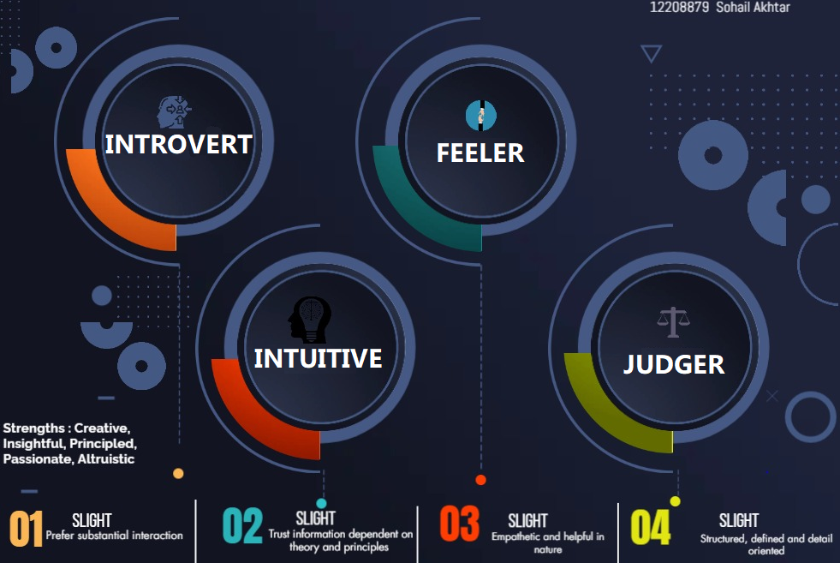

EXTRA CURRICULAR ACTIVITIES

Member of National Service Scheme (NSS)

Member of Student organization Tachyons working in Event management

OBJECTIVE

To Enhance my professional skills, capabilities and knowledge in an organization which recognizes the value of hard work and trust me with responsibilities and challenges

PROJECTS

WATER WESTAGE WEBSITE

Domain: Web Programming Languages:Html,Css, Javascript, Constructed an Website to raising awareness about water westage and also there are some tips like how to save water.

ONLINE REAL ESTATE WEBSITE

Domain: Web Programming Languages:Html,Css, Javascript,

By using these programming language we created a website in this website user can sell or buy flat homes .

CA EVALUATION SYSTEM

Domain: C | Programming Languages language I have used in this project and in this project first of all we have to store the information of the student after that we can fetch the marks.

We can update , delete ,display the records of the student

This is a group project of three members.

ACHIEVEMENTS

Achieved first rank in General knowledge and aptitude test in my school

I have worked in a National level Event Ayurvedya Kumbh organized in Ayodhya

And I have worked in An Event Named Hridyam in Technical team organized in Vrindavan

EDUCATION

B.Tech. in Computer Science August '22 - Lovely Professional University | Phagwara, IN

Senior Secondary Education July '18 - Mar '20

Ssv Inter College |Ayodhya, Up

Secondary Education July '20 - Mar '22

Ssv Inter College |Ayodhya, Up